Software Project Management Plan (SPMP)

For

Fleet Management System

Submitted By

M Muhammed Aqeel, Yashwanth Karuparthi

Date

Table of Contents

1. Introduction

1.1. Project Overview

1.2. Project Deliverables

1.3. Evolution of SPMP

1.4.References

1.5. Definitions and Acronyms

2. Project Organization

2.1. Process Model

2.2. Organizational Structure

2.3. Organizational Boundaries

2.4. Project Responsibilities

3. Managerial Process

3.1. Management Objectives & Priorities

3.2. Assumptions, Dependencies & Constraints

3.3.Risk Management

3.4. Monitoring and Controlling Mechanisms

3.5. Staffing Plan

4. Technical Process

4.1. Methods, Tools and Techniques

4.2. Software Documentation

4.3. Project Support Functions

5. Work Packages, Schedule, and Budget

5.1. Work Packages, Schedule, and Budget

5.2. Dependencies

5.3.Resource Requirements

5.4.Budget and Resource Allocation

5.5. Schedule

6. Additional Components

6.1.Index

**1. Introduction**

1.1. Project Overview

The objective of this project is to design and develop a plan for a fleet management system. This project is a web-based application software which is aimed to streamline and optimize the management of vehicles, drivers, and associated resources by leveraging real-time insights and seamless coordination of tasks, ensuring better efficiency, cost-effectiveness and safety in fleet operations.

1.2. Project Deliverables

The project deliverables include various components essential for the successful development and deployment of the fleet management software. This includes comprehensive documentation detailing the implementation process. These documents provide valuable insights for future modifications and enhancements to the software. Additionally, design documents and project plans are included in the initial stages to provide a blueprint for the development process. Finally, the project aims for the delivery of the fully functional fleet management software, ready for deployment and use by stakeholders.

1.3. Evolution of SPMP

The Software Project Management Plan (SPMP) for this project will evolve throughout the development lifecycle, adapting to changing requirements and circumstances. Initially, it will outline the project scope, objectives, and stakeholders' roles and responsibilities. As the project progresses, the SPMP will be updated to include detailed schedules, resource allocation, risk management strategies, and quality assurance measures. Regular reviews and updates will ensure that the SPMP remains relevant and effective throughout the project's lifecycle.

1.4. References

Steve McConnell, Software Project Survival Guide, Microsoft Press, 1998.

Hunt, A., & Thomas, D. (1999). The Pragmatic Programmer: Your Journey to Mastery. Addison-Wesley.

Schwaber, K., & Sutherland, J. (2017). The Scrum Guide: The Definitive Guide to Scrum: The Rules of the Game. Scrum.Org.

Kerzner, H. (2017). Project Management: A Systems Approach to Planning, Scheduling, and Controlling. Wiley.

Pressman, R. S. (2014). Software Engineering: A Practitioner's Approach. McGraw-Hill Education.

Bass, L., Clements, P., & Kazman, R. (2012). Software Architecture in Practice. Addison-Wesley.

1.5. Definitions and Acronyms

Fleet Management System (FMS): A software solution designed to manage and optimize the operations of a fleet of vehicles.

SPMP: Software Project Management Plan.

RDBMS: Relational Database Management System

jUnit: Popular open-source framework for writing and running automated tests in Java

PMO: Project Management Office

GPS: Global Positioning System.

**2 Project Organization**

2.1 Process Model

The project adopts Scrum framework as chosen model considering the project’s dynamic nature and the need for iterative development and continuous feedback. Scrum is a widely used agile methodology that promotes flexibility, collaboration, and adaptability throughout the software development life cycle.

Due to its iterative nature and focus on user feedback, the Scrum framework is suitable for developing the project. Working in short sprints allows for core functionalities to be built first, with user feedback guiding further iterations and refinements. This adaptability is crucial for projects where features might evolve based on user needs, like integrating telematics data or optimizing routes.

2.2 Organizational Structure

The organization developing this product is a start-up. The organization is handled by the managing director. A project manager is handling all the projects of the organization and reporting to the managing director. Then there are developers in the organization. They are assigned different designations based on the skills they possess among the frontend, backend and database development. Also, some testers are responsible for the code review for the projects. Two employees are there for maintaining code revision with Git and do the deployment of the product on the Cloud.

2.3 Organizational Boundaries

All the requirements by the clients are handled by the project manager in the team. He is responsible for communicating any requirements in the team to the managing director. The project manager will be dealing and talking to clients for modifications and report the development progress. If any modifications or changes affect the milestones or the budget of the project then that has to be first discussed with the managing director of the organization.

2.4 Project Responsibilities

The responsibilities of the various positions are described below:

* Product Manager:
  + Communicates with the customer
  + Drafts initial requirements
  + Verifies that all customer’s requirements are met
  + Researches existing/competing products
* Project Manager:
  + Leads the project’s development and testing
  + Elaborates on initial requirements (in meeting with developers)
  + Verifies that all requirements received from the Product Manager are met by the code.
* Software Quality Assurance/Tester
  + Systems Testing
* Designer/Developer
  + Prototypes
* Requirements Engineer:
  + Generates requirements and dependencies
* Customer/Client:
  + Defines the requirements

**3. Managerial Process**

3.1. Management Objectives & Priorities

The management objectives and priorities for our Fleet Management Systems project are centered around enhancing the efficiency, safety, and cost-effectiveness of fleet operations. Our primary objectives include:

* Improving Efficiency: Streamlining fleet operations to reduce idle time, optimize routes, and increase overall productivity.
* Reducing Costs: Minimizing fuel consumption, maintenance expenses, and vehicle downtime through effective management and optimization.
* Enhancing Customer Service: Improving delivery times, accuracy, and reliability to enhance customer satisfaction and loyalty.

Priorities revolve around achieving these objectives within the allocated budget and timeline while ensuring the solution meets the needs and expectations of all stakeholders, including fleet managers, drivers, and customers.

3.2. Assumptions, Dependencies & Constraints

In the development of the Fleet Management System, we are operating under several assumptions, dependencies, and constraints:

Assumptions:

* Availability of necessary hardware and software components.
* Availability of reliable data sources for vehicle tracking and route optimization.
* Cooperation from fleet operators and drivers in adopting and using the new system.
* Adequate training and support for users during the implementation phase.

Dependencies:

* Integration with GPS and telematics devices for real-time vehicle tracking.
* Availability of internet connectivity.

Constraints:

* Budget constraints may limit the scope of the project and available resources.
* Time constraints may impact the development and implementation timeline.
* Regulatory constraints regarding data privacy and security must be adhered to.

Addressing these assumptions, dependencies, and constraints is crucial for the successful execution of the project.

3.3. Risk Management

Effective risk management is essential to mitigate potential threats and uncertainties that could impact the success of the project. We have identified several risks associated with our Fleet Management System project, including:

* Technical Risks: Such as software bugs, compatibility issues, or hardware failures.
* Operational Risks: Such as resistance to change from users, inadequate training, or data quality issues.
* External Risks: Such as regulatory changes, economic fluctuations, or disruptions in supply chains.

Proactive risk management strategies are implemented, including risk identification, assessment, mitigation, and monitoring, to minimize the impact of these risks on the project's objectives.

3.4. Monitoring and Controlling Mechanisms

To ensure the project stays on track and meets its objectives, we will implement robust monitoring and controlling mechanisms. This includes:

* Regular progress reviews to track the development and implementation progress against the project plan.
* Performance metrics to measure key indicators such as efficiency gains, cost savings, and customer satisfaction.
* Issue tracking and resolution to address any obstacles or challenges encountered during the project lifecycle.
* Change management processes to handle any deviations from the original plan effectively.

These mechanisms will enable us to identify and address any issues promptly, ensuring the successful delivery of the Fleet Management System.

3.5. Staffing Plan

Our staffing plan includes a dedicated team with the necessary expertise to develop and implement the Fleet Management System. The team consists of:

* Project Manager: Responsible for overall project planning, coordination, and communication with stakeholders.
* Software Developers: Responsible for designing, coding, and testing the software components.
* Database Administrators: Responsible for managing the database infrastructure and ensuring data integrity.
* Quality Assurance Analysts: Responsible for testing the software to ensure it meets quality standards and specifications.
* Technical Support Staff: Responsible for providing user training, technical support, and troubleshooting assistance.

Each team member will contribute their expertise to ensure the successful completion of the project within the specified timeframe and budget. The execution team is needed for the entire 13 weeks for development purposes. The developers are needed for 8 weeks to carry out the development works. Testers are needed for the last 5 weeks to do the final testing of the software.

A deployment team is needed after the final testing and completion of the project to deploy the system to the cloud.

**4. Technical Process**

4.1. Methods, Tools and Techniques

In the development of our Fleet Management System, we will utilize a variety of methods, tools, and techniques to ensure the successful implementation of the project.

Development Methodology: Scrum framework is used, allowing for iterative development cycles and continuous feedback from stakeholders.

Programming Languages and Frameworks: Java, Javascript and Python frameworks-Django and Flask, are primarily used for developing the web-based software, along with Ruby on Rails for backend development and React.js for frontend development.

Database Management: An RDBMS, PostgreSQL to store and manage data related to vehicles, routes, drivers, and retailers. Additionally, data modeling techniques will be implemented to ensure efficient storage and retrieval of information.

Vehicle Tracking and Telematics: For real-time vehicle tracking, GPS technology is integrated with telematics devices. This allows to monitor the location, speed, and status of vehicles in the fleet, providing accurate data for route optimization and performance analysis.

Testing and Quality Assurance: Automated testing frameworks are employed such as JUnit and Selenium for unit testing and integration testing, ensuring the reliability and functionality of the software.

4.2. Software Documentation

Software documentation will be done by individuals working on the developments and testing of the software upon completing their tasks, which will include:

Technical Specifications: Detailed specifications outlining the system architecture, modules, interfaces, and data structures.

User Manuals: User-friendly manuals providing instructions on system installation, configuration, and usage.

API Documentation: Documentation for APIs exposed by the system, including endpoint descriptions, request/response formats, and authentication mechanisms.

Code Documentation: Inline comments and documentation explaining the purpose and functionality of each code module and function.

Change Logs: Records of changes made to the software, including bug fixes, enhancements, and version updates.

Test Cases: All the test cases are to be properly documented.

4.3. Project Support Functions

To ensure the smooth execution of the project, various support functions will be established to provide assistance and resources as needed:

Project Management Office (PMO): The PMO will oversee project planning, resource allocation, and risk management, ensuring that the project stays on track and meets its objectives.

Technical Support Team: A dedicated technical support team will be available to provide assistance to users, address technical issues, and troubleshoot system problems.

Training and Knowledge Transfer: Training sessions will be conducted to educate users on how to use the Fleet Management System effectively. Additionally, knowledge transfer sessions will be held to transfer expertise from the development team to the operational team.

Documentation Management: A documentation management team will be responsible for maintaining and updating software documentation, ensuring that it remains accurate and up-to-date throughout the project lifecycle.

**5. Work Packages, Schedule, and Budget**

5.1. Work Packages, Schedule, and Budget

In the development of the Fleet Management System, we have organized the project into distinct work packages, each with specific deliverables, schedules, and budget allocations.

Our project is divided into several work packages, including software development, testing, documentation, training, and implementation. Each work package is further broken down into tasks and activities to facilitate efficient execution.

5.2. Dependencies

Technical Dependencies: Dependencies related to software and hardware requirements, such as the availability of development tools, compatibility with existing systems, and integration with third-party services.

Resource Dependencies: Dependencies on personnel and external resources, including availability of skilled developers, access to specialized equipment, and availability of training resources.

Dependency Management: We will actively monitor and manage dependencies throughout the project lifecycle, addressing any issues promptly and adjusting the project plan as necessary to mitigate risks.

5.3. Resource Requirements

Each developer requires one Windows-installed PC with 8 GB minimum RAM with various web development tools. Tools required are to be purchased by the organization if they are paid services for the development. High-performance servers and networking equipment will also be required to host the web application, database and associated services.

5.4. Budget and Resource Allocation

| Phase | No. of People | Budget | No. of Hours/Days |
| --- | --- | --- | --- |
| Requirements Gathering | Manager | NA | NA |
| System Design and Architecture | Lead & Developers | Aed 80/hour | 2 weeks |
| Implementation | Lead & Developers | Aed 80/hour | 4 weeks |
| Testing | Testers | Aed 60/hour | 2-3 weeks |
| Deployment | Deployment Team | Aed 60/hour | 3 weeks |
| Total | 11 | Aed 33,600 | 3 months (estimated) |

5.5. Schedule

The below Ghantt chart represents the schedule planned for the project:

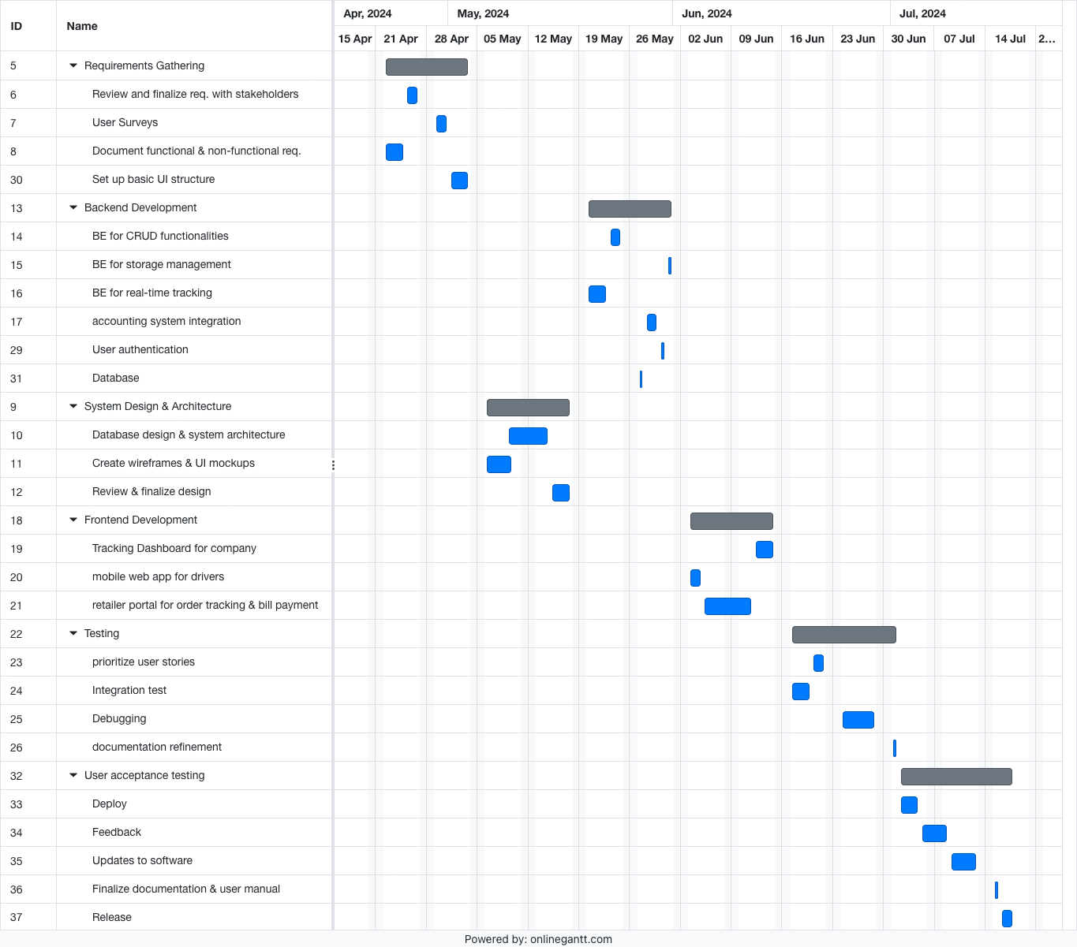

**6 Additional Components**

6.1 Index

Training - A thorough walk-through of the system will be given to the users of the system to make them aware of the flow of the system. This training will be given by the project manager. Also, post-release maintenance and support will be provided by the organization for one year.

Project Schedule - The project schedule section outlines the timeline for the project, including major milestones, key activities, dependencies, and resource allocation.

Project Organization - Describes the organizational structure of the project team, including roles and responsibilities of team members, reporting hierarchy, and communication channels.

Budget and Resource Management - Details the project budget, including cost estimates, expenditure tracking, and resource allocation.